**Salesforce Project Implementation Phases**

**Phase 4: Process Automation (Admin)**

In this phase, I automate business processes in Salesforce to reduce manual work, ensure data quality, and improve patient care efficiency. We use **Validation Rules, Workflow Rules, Process Builder, Approval Processes, Flow Builder, and Notifications** tailored for Telemedicine CRM.

* **Validation Rules**

Validation Rules ensure data accuracy before records are saved.

* **Patient Aadhaar Validation**

- Object: Patient__c

- Rule: Aadhaar_Number__c must be 12 digits.

- Formula: NOT(REGEX(Aadhaar_Number__c, "[0-9]{12}"))

- Error: " Please enter a valid 12-digit Aadhaar number."

* **Appointment Date Check**

- Object: Appointment__c

- Rule: Appointment_Date__c must be greater than TODAY().

- Error: "Appointment date cannot be in the past."

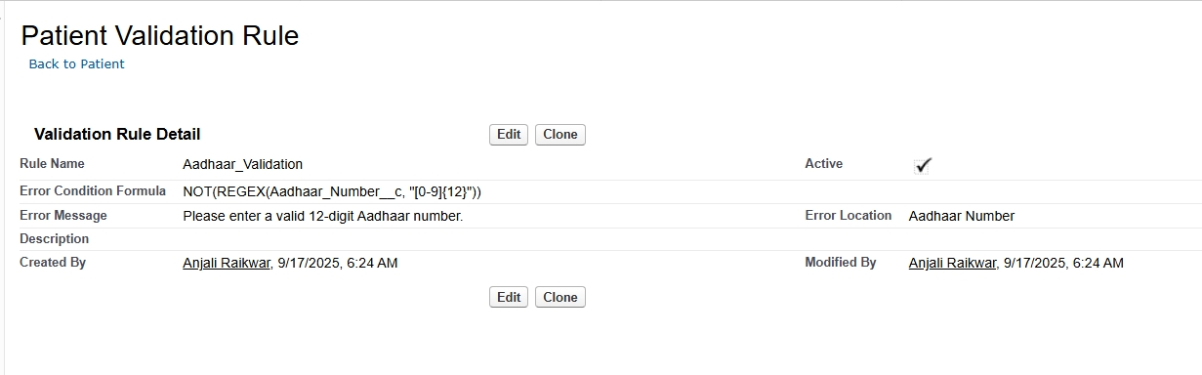

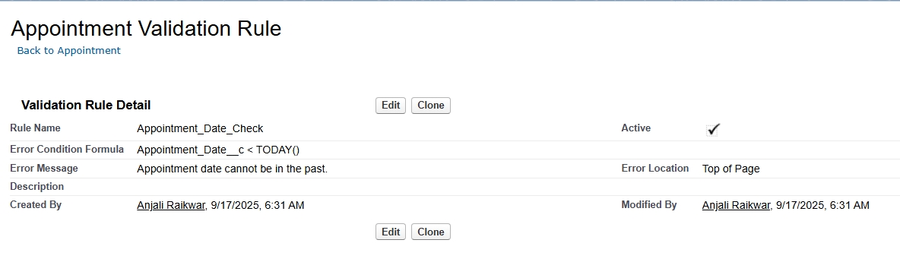

* **Workflow Rules**

Workflow Rules help automate simple actions.

**Send Email Reminder**

- Object: Appointment__c

- Condition: Appointment_Date__c = Tomorrow.

- Action: Send email alert to Patient__c.Email and Doctor__c.Email.

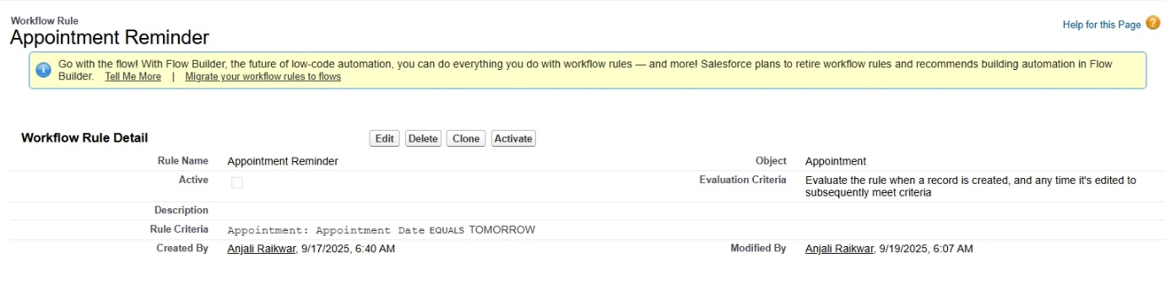

**Medicine Stock Low**

- Object: Medicine__c

- Condition: Quantity__c < 10.

- Action: Send notification to Pharmacy Staff.

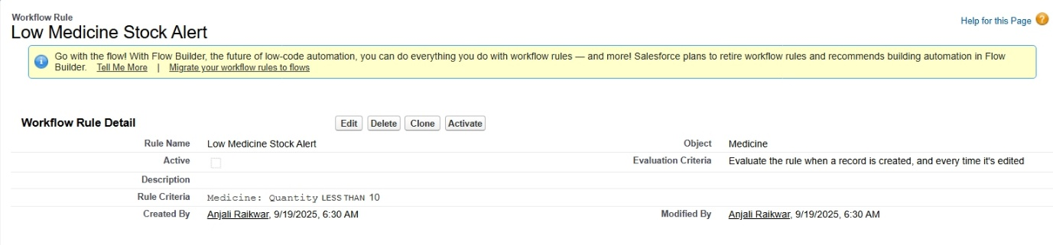

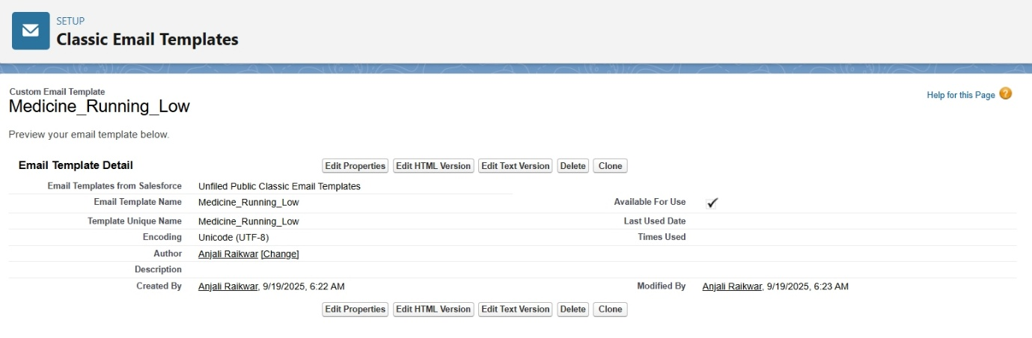

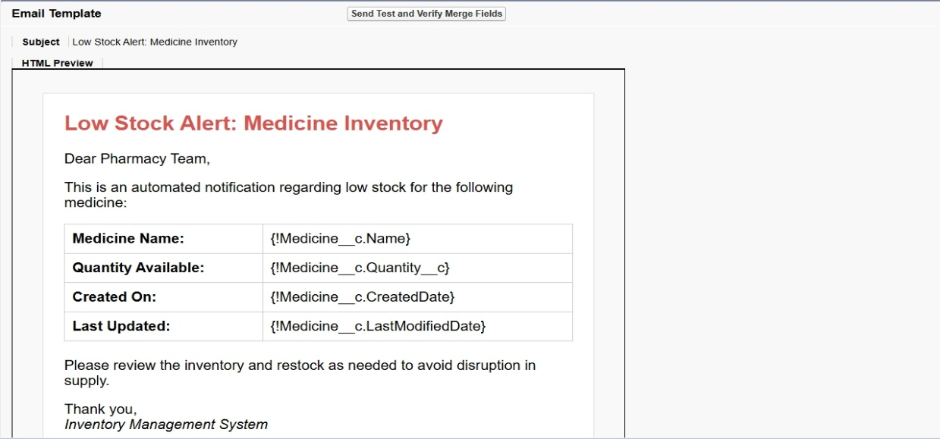

* **Process Builder**

Process Builder is used for slightly complex automation with if/else logic.

**Auto-Assign Doctor**

- Object: Appointment__c

- Criteria: Specialization__c = "Cardiology"

- Action: Assign to Doctor__c where Doctor.Specialization__c = "Cardiology".

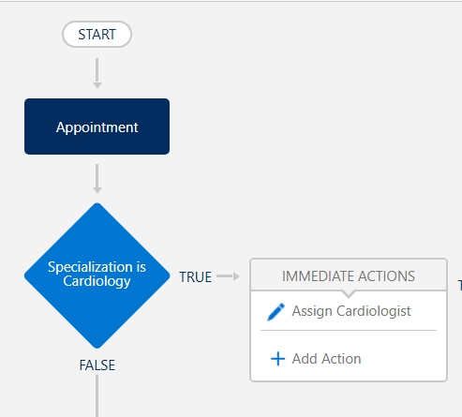

**Update Patient Last Visit**

- Object: Appointment__c

- Action: Update Patient__c.Last_Visit_Date__c with Appointment_Date__c when

appointment is completed.

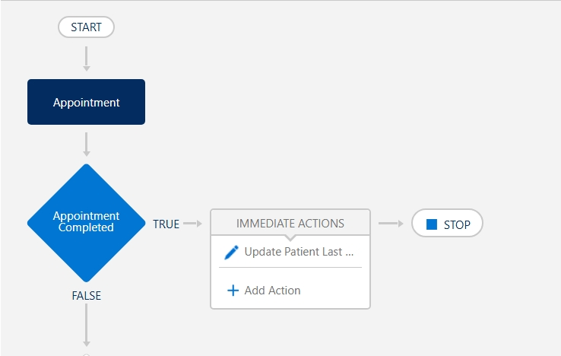

* **Approval Process**

Approval processes help manage requests that need authorization.

**Medicine Restock Request**

- Object: Medicine__c

- Criteria: Quantity__c < 5

- Step 1: Pharmacy Staff submits a restock request.

- Step 2: Approved by Hospital Admin.

- Step 3: Once approved → Purchase order is created (custom object: Purchase_Order__c).

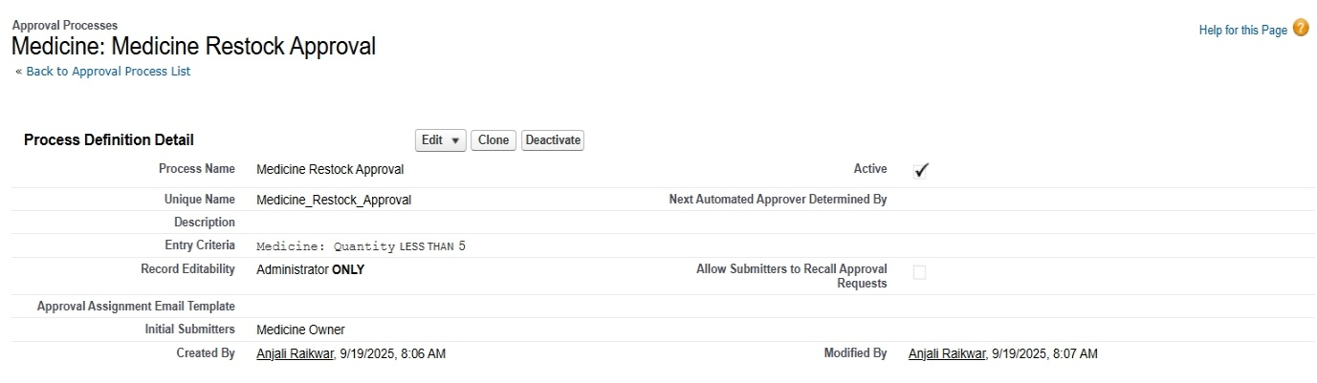

* **Flow Builder**

Flows provide advanced automation (Screen Flows, Record-Triggered, Auto-launched).

**Screen Flow: New Patient Registration**

- Collect Aadhaar, Name, Age, Symptoms.

- Auto-create Patient__c record + Initial Appointment__c.

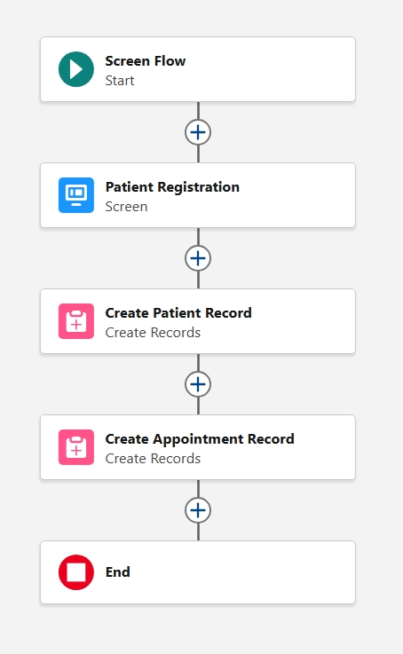

**Record-Triggered Flow: Appointment Reminder**

- Trigger: 1 day before Appointment__c.Appointment_Date__c

- Action: Send WhatsApp/SMS/Email to patient.

**Scheduled Flow: Expiring Medicine Notification**

- Run daily at 10 AM.

- Check Medicine__c.Expiry_Date__c = TODAY() + 2.

- Send alert to Pharmacy Staff.

* **Email Alerts**

Email templates + alerts linked with rules and flows.

- Appointment Confirmation Email → Patient & Doctor.

- Low Inventory Email → Hospital Admin.

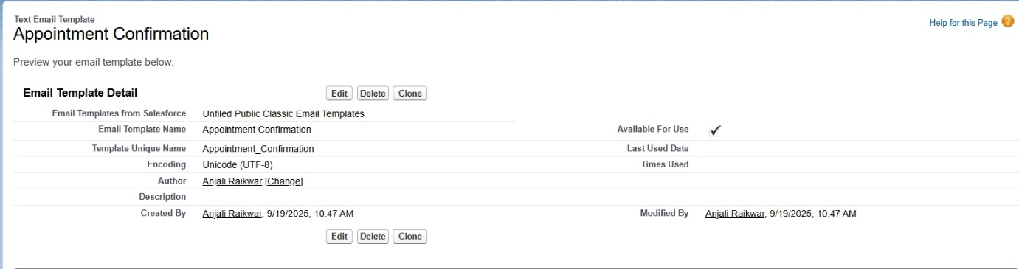

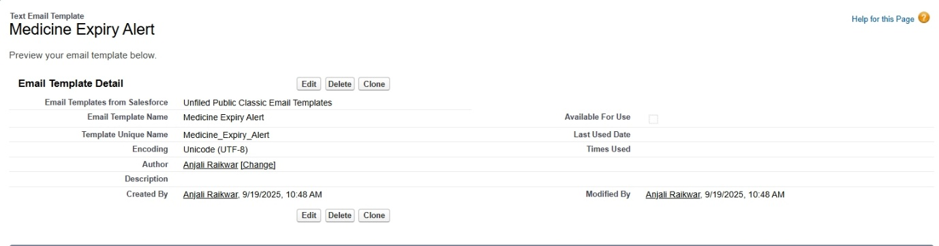

* **Field Updates**

Automatically update fields.

- Appointment__c.Status__c → "Completed" when Doctor marks Consultation Complete.

- Patient__c.Last_Consulted_Doctor__c → Auto-updated on new appointment.

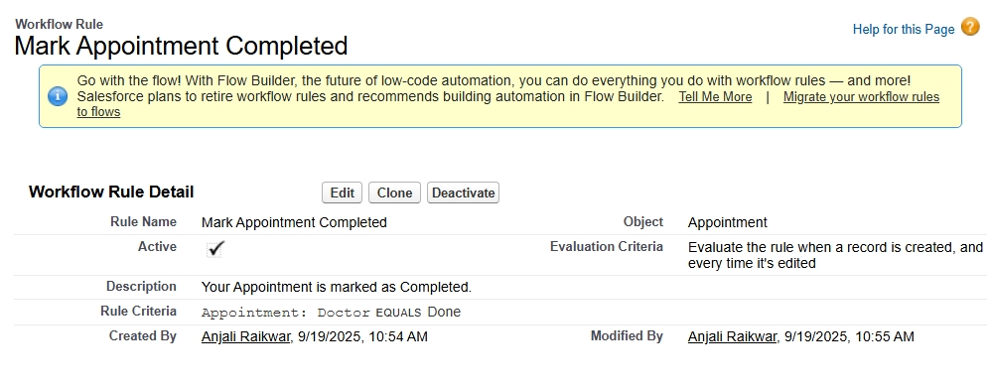

* **Tasks**

Assign tasks automatically.

- If Appointment is missed → Auto-create Task for Doctor to follow up with patient.

* **Custom Notifications**

Use in-app and mobile notifications.

- Notify Doctor: "New appointment assigned."

- Notify Pharmacy: "Paracetamol stock below 10 units."

- Notify Patient: "Your appointment with Dr. Sharma is tomorrow at 10:30 AM."

